A Project Report on

“Pet Adoption platform”

Submitted in the partial fulfillment of the requirements
for the award of the degree of
MASTER OF TECHNOLOGY
COMPUTER SCIENCE ENGINEERING
By

2501050180 VARIKUTI DEEPTHI

Under the esteemed guidance of
Dhinesh kumar
Assistant Professor

Course: Front-end Frameworks

Department Of Computer Science Engineering
KL University



Department of Computer Science & Engineering
K L E F, Green Fields,
Vaddeswaram- 522502, Guntur (Dist.), Andhra Pradesh, India.
2025-2026

Declaration

The Project Report entitled “PET ADOPTION PLATFORM”is a record of Bonafide work of V.DEEPTHI (2501050180) submitted in partial fulfillment for the award of MTech in Computer science and engineering to the KL University. The results embodied in this report have not been copied from any other departments/University/Institute.

Name of the Student Signature of the Students
V.DEEPTHI(2501050180)

CERTIFICATE

This is to certify that the Project Report entitled “ PET-ADOPTION PLATFORM” is being submitted by V.DEEPTHI (2501050180)

) submitted in partial fulfillment for the award of M.Tech in Computer science and engineering to the K L University. The results embodied in this report have not been copied from any other departments/University/Institute. The results embodied in this report have not been copied from any other departments University/Institute.

Signature of the Supervisor
Name and Designation

Signature of the HOD Name & Signature of the External Examiner
Date:

ABSTRACT

The Pet Adoption platform is a user-friendly web platform designed to simplify the process of finding and adopting pets online. Many people struggle to identify suitable pets due to scattered information, unclear details, and lack of proper selection tools. This project addresses that problem by creating a centralized adoption system where users can explore pets, mark their favorites, and submit an adoption request through a dedicated form.The portal provides key features such as species-based filtering, interactive pet cards, a Favorites page for quick access, and a fully functional adoption form that collects essential user details. The system uses HTML, CSS, JavaScript, and JSON to manage pet data, along with browser local Storage for handling selections and form submissions. Overall, the project results in a simple, responsive, and effective adoption platform that helps users easily choose a pet and initiate the adoption process online.

Table of contents:

Sno | Content | Page no
1 | Introduction | 6
2 | Problem Definition | 7
3 | Objectives | 8
4 | Scope of the project | 9-10
5 | Literature survey | 11-12
6 | System Requirements | 13-16
7 | System Design | 17-21
8 | Testing | 22-27
9 | Results | 28-34
10 | Conclusions | 35-36
11 | Future Enhancements | 37-38
12 | References | 39-40

INTRODUCTION

The growing number of abandoned and shelter-dependent animals highlights the need for accessible adoption systems. Many potential pet owners are willing to adopt, yet they struggle to find clear, organized, and trustworthy information about available pets. Traditional adoption processes often involve physically visiting shelters, relying on outdated listings, or browsing scattered social media posts. This leads to delays, confusion, and even missed opportunities for both adopters and pets.
A dedicated Pet Adoption Portal solves this problem by providing a structured and transparent platform where users can view pets, understand their characteristics, and initiate adoption easily. Its importance lies in bridging the gap between animal shelters and people who genuinely want to bring home a companion. By simplifying the search and selection process, the system encourages more successful adoptions and reduces the time pets spend in shelters.
This project is mainly useful for animal lovers, families looking to adopt pets, students because digital adoption platforms are still limited, especially those offering personalized features such as favorites, filters, and detailed pet profiles. A streamlined, responsive, and user-friendly system ensures that people can make informed decisions from the comfort of their home.

PROBLEM DEFINITION

In today’s world, a large number of animals in shelters and rescue centers are in need of safe and loving homes. At the same time, many people genuinely want to adopt pets but struggle to find the right platform that gives them complete, reliable, and neatly organized information. Most adoption processes still depend on scattered social media posts, word of mouth, or visiting shelters physically. This makes the process slow, inefficient, and confusing for both adopters and shelters. The absence of a unified digital system becomes a major barrier between animals waiting for families and people searching for pets.
A major issue is the lack of a centralized portal where users can browse pets easily with proper details like breed, age, gender, and temperament. Potential adopters often see low-quality photos, incomplete descriptions, or outdated information, which reduces their confidence in adopting. Many people also hesitate because they cannot track or shortlist pets they like, leading to frustration and loss of interest. On the other side, shelters struggle to present their animals effectively, reach a wider audience, or manage adoption requests smoothly, resulting in longer waiting times for animals to get adopted.
Another pain point is communication. Even if someone is interested in adopting a pet, the next steps are often unclear. Adopters don’t know whom to contact, what details to submit, or how long the process will take. Shelters receive incomplete messages, face delays in gathering adopter information, and have difficulty maintaining records. This slows down the adoption cycle and creates unnecessary complications. A streamlined and digital approach is urgently needed to solve these issues.
The purpose of this project is to build a user-friendly Pet Adoption Portal that brings everything into a single, accessible system. It allows users to explore animals with proper images and details, mark favorites, and submit an adoption form quickly through an organized interface. By simplifying the process, the system increases the chances of successful adoptions while ensuring transparency and convenience for users. It also reduces the workload of shelters by collecting complete and validated adopter information automatically.
Ultimately, this project aims to bridge the gap between pet seekers and animal shelters by providing a clear, well-designed, and efficient platform. With an easy way to view pets, save favorites, and complete adoption requests, the system encourages responsible adoption and helps more animals find their forever homes. This digital solution improves accessibility, solves communication issues, and creates a smooth experience for both adopters and organizations, making pet adoption faster, better, and more effective.
OBJECTIVE

The primary objective of this project is to develop a highly interactive, user-friendly application that demonstrates modern frontend development practices while delivering efficient functionality. To achieve this, the project focuses on building a clean, responsive, and intuitive UI capable of handling real-time interactions and dynamic data rendering. The following specific objectives guide the development process:
- To design a visually appealing and responsive user interface (UI)
This project aims to create a frontend that automatically adapts to different screen sizes, ensuring smooth usability on mobile, tablet, and desktop devices. The UI will follow modern design principles such as minimalism, consistent color themes, structured layouts, and accessibility standards.
- To enhance user experience through modern UI components and seamless navigation
The system will incorporate interactive elements such as dynamic cards, smooth transitions, responsive buttons, modals, and tooltips. These components aim to make user interaction engaging, simple, and efficient while reducing the cognitive load on the user.
- To integrate real-time data handling using APIs or simulated data sources
The project plans to fetch, process, and display data instantly without page reloads. This ensures that users receive up-to-date information and experience smooth, asynchronous interactions powered by technologies like Fetch API or Axios.
- To implement strong input validation and error-handling mechanisms
User entries will be carefully validated to prevent incorrect data submission. Both client-side validation (using JavaScript) and meaningful error messages will guide users toward correct inputs and improve the overall reliability of the system.
- To ensure modular, maintainable, and reusable frontend architecture
The project will be structured using component-based design and clean coding standards. This allows future enhancements, code readability, and scalability of the application without significant redevelopment effort.
- To optimize the system for performance, speed, and smooth operation
Techniques such as lightweight component rendering, reduced DOM manipulation, and optimized resource loading will be used to ensure fast page load times and responsive user interactions, even on low-performance devices.
- To create a solution that can be used for real-world demonstration and learning
The final system will serve as a practical model to understand frontend workflows, UI/UX concepts, and real-time interaction handling—making it useful for academic submissions, portfolio display, or demonstrations of modern web development skills.
SCOPE OF THE PROJECT

The scope of this project defines the features, boundaries, and extent of functionality that the system will provide. It outlines what the system aims to achieve, the modules included in the final implementation, and any limitations or features that are intentionally excluded. The project focuses primarily on delivering a clean, responsive, and interactive frontend interface with essential data handling and validation features suitable for real-world demonstration and academic use.

Features Included:
- Responsive User Interface Design
The system will support multiple screen sizes and resolutions, ensuring seamless usage on mobile, tablet, and desktop devices using flexible layouts and adaptive styling.
- Modern UI Components & Interactions
The application includes structured elements such as buttons, cards, forms, navigation bars, modals, and dynamic elements that contribute to a smooth and engaging user experience.
- Real-Time Data Display
The system will fetch, load, and display data dynamically using APIs or simulated endpoints. Users can view updated information without page reloads through asynchronous operations.
- Form Handling & Input Validation
The project provides clean and validated input forms, ensuring users submit correct data. Error messages and feedback indicators are included for better clarity.
- Smooth Navigation & User Flow
Users can move between different UI sections or features effortlessly, supported by an intuitive layout and clear content segmentation.
- Frontend-Only Architecture
The system is built purely on frontend technologies, making it lightweight and easy to deploy for demonstration or portfolio purposes.
- Clean, Maintainable Codebase
The project follows modular code practices, enabling easy expansion, debugging, and future enhancements.

Features Excluded:
- Backend Database Storage
No permanent data storage or server-side database systems like MySQL, Firebase, or MongoDB are included.
- User Authentication System
Features like login, signup, password reset, or role-based authentication are not part of this project.
- Advanced Data Analytics or AI Models
No machine learning algorithms or complex analytics modules will be processed within this version.
- Payment Gateways or Financial Transactions
The project does not include any transaction-based or e-commerce-related functionalities.
- Admin-Level Dashboards
Only basic UI interactions are included; advanced admin portals are outside the scope.

User Roles
Since this is a frontend-focused system, the project operates primarily with a single user role.
End User
- Can interact with the UI
- Can view dynamic data
- Can fill and submit forms
- Can navigate between interface sections

LITERATURE SURVEY

Several well-known pet adoption websites and mobile applications provide online listings, adoption support, and basic user interaction. However, each has its limitations, which creates scope for developing an improved and simplified adoption system like the one proposed in this project.

1. Pet-finder
Features:
1.Large database of pets from multiple shelters across regions
2.Search filters for breed, age, gender, and location
3.Provides photos, descriptions, and adoption guidelines
4.Offers mobile app & website accessibility
Limitations:
1.Overwhelming interface for new users due to too many options
2.Slow performance on low-end devices
3.Too much information scattered across multiple pages
4.No simple and minimal UI version for small shelters or academic projects
Difference from the Proposed System:
1.Our project focuses on a simple, clean, and lightweight UI
2.Minimalistic flow for browsing, selecting, and adopting a pet
3.Suitable for smaller-scale use, demonstrations, and educational purpose.

2. Adopt-a-Pet
Features:
1.User-friendly website with pet listings and shelter contact details
2.Offers tools for shelters to upload and manage pet profiles
3.Provides email alerts for new pet postings
4.Includes verified adoption partner organizations
Limitations:
1.No real-time interaction; data updates are slow
2.Not responsive enough for some screen sizes
3.Heavy backend dependency makes the system complex
4.Adoption forms often redirect to external pages
Difference from the Proposed System:
1.Our system provides instant form access directly from pet cards
2.Fully responsive frontend for mobile and desktop
3.Designed to load faster with no backend dependency
4.Ideal for quick adoption requests without external redirections

3. Local NGO or Shelter Websites
Features:
1.Provide basic pet listings with photos and short descriptions
2.Simple contact forms for adoption queries
3.Some include store or donation sections
Limitations:
1.Poor UI/UX and outdated designs
2.No favorites page or user personalization
3.Limited information about pets
4.Forms are not dynamic and often lack validation
Difference from the Proposed System:
1.Our system includes a Favorites page, enhancing user engagement
2.Dynamic, validated Adoption Form linked to specific pets
3.Modern UI with responsive layout
4.Cleaner information display and interactive pet cards

SYSTEM REQUIREMENTS
- Software Requirements

HTML5:

HTML5 forms the foundational structure of the Pet Adoption Portal and is used to build every page, including the Home, Adopt, Favorites, and Adoption Form pages. In this project, HTML5 provides the semantic layout that organizes the user interface into intuitive sections such as navigation bars, pet listing grids, image containers, and form fields. It ensures that the content is cleanly structured and easily readable both by browsers and users. Elements such as <section>, <header>, <footer>, <div>, <img>, and <form> are used extensively to define the structure of the portal. HTML5 also enables responsive behavior and modern attributes like required, type="email", and type="tel" to support basic validation in the adoption form. Since the project is entirely client-side and does not rely on server-side rendering, HTML5 plays a crucial role in creating a smooth, static yet dynamic-feeling experience for users. It ensures compatibility across all modern browsers, making the portal accessible on desktops, tablets, and mobile devices.Advanced HTML focuses on writing semantic, accessible, and well-structured markup rather than just displaying content. HTML5 elements like header, footer, section, article, and aside improve document meaning, accessibility, and SEO. Features such as custom data attributes allow better integration with JavaScript, while advanced form elements and built-in validation APIs reduce dependency on external scripts. Proper use of ARIA roles, labels, and landmarks ensures compatibility with screen readers, making applications inclusive and standards-compliant.

CSS3:

CSS3 is used to design and beautify the entire user interface of the Pet Adoption Portal. It transforms plain HTML structures into an engaging and user-friendly platform by applying styles to buttons, layout grids, navigation sections, pet cards, and adoption forms. The project uses CSS3 for spacing, alignment, responsive scaling, animations, shadows, rounded corners, and consistent typography to enhance readability. Each page — whether it is the Adopt page showing all pets or the Favorites page displaying saved pets — uses CSS3 styling to ensure a visually appealing and modern look. The adoption form is also styled using CSS3 to create a clean, card-based appearance with smooth shadows and soft borders. Additionally, CSS3 makes the layout completely responsive using relative units like percentages and flexible image styling such as object-fit: contain. Because the portal handles multiple pet cards and varying image sizes, CSS ensures that visual elements remain aligned, neat, and aesthetically pleasing on any screen size.At an advanced level, CSS is used to create responsive, scalable, and visually rich user interfaces. Layout systems like Flexbox and CSS Grid enable complex designs with minimal code, while media queries and container queries allow layouts to adapt across devices. CSS variables improve maintainability and theming, and advanced selectors, pseudo-classes, and pseudo-elements enhance styling precision. Transitions, transforms, and keyframe animations add smooth interactions, and performance-focused practices such as minimizing repaint and reflow are essential in large-scale applications.

3. JavaScript (Vanilla JavaScript)
JavaScript is the core engine behind the project's interactive functionality. In this Pet Adoption Portal, pure JavaScript (without frameworks) handles all dynamic operations — the retrieval of pet data from the pets.json file, population of pet cards, filtering by category, management of favorites, and display of selected pet details in the adoption form. It uses the Fetch API to load the pet dataset and dynamically generate HTML elements based on the JSON content. JavaScript also manages key features like "Add to Favorites," “Remove from Favorites,” and “Adopt Now,” all of which operate through the browser’s LocalStorage. Additionally, it ensures that when a user selects a pet for adoption, the system remembers the choice and displays the correct details on the form page. JavaScript also validates user inputs such as phone number and email, ensuring that the data entered is correct and complete. By controlling the flow between pages, updating UI elements, and handling state management without a backend, JavaScript plays the most crucial role in making the entire portal function like a mini-application rather than a static website.Advanced Vanilla JavaScript emphasizes performance, modularity, and asynchronous programming. Concepts such as closures, the event loop, and scope management help in writing efficient and predictable code. Asynchronous behavior is handled using Promises, async/await, and the Fetch API for seamless API communication. Techniques like event delegation, debouncing, throttling, and lazy loading optimize performance, while DOM manipulation, state management without frameworks, and ES6+ features (modules, arrow functions, destructuring) enable the development of robust, framework-independent web applications.

4. JSON (pets.json Data File)
The pets.json file acts as a lightweight data source for the portal. It stores essential information about every pet, such as its ID, name, breed, age, gender, description, and image path. Instead of using a database or server API, this project relies on JSON as a static dataset that can be fetched using JavaScript. When the portal loads, JavaScript reads the JSON file and transforms each entry into a visual card on the Adopt page. This approach makes the project simple, fast, and ideal for offline or front-end-only deployments. JSON ensures that the pet data is neatly organized, easy to update, and easily readable by the browser. Since each pet entry is stored with a unique ID, the adoption form and favorites system can reference them accurately. JSON acts as the heart of the data layer and keeps the entire project lightweight and efficient without requiring backend technologies.JSON (JavaScript Object Notation) is a lightweight, text-based data interchange format widely used for client–server communication and configuration management in web applications. At an advanced level, JSON is handled through structured parsing and serialization using JSON.parse() and JSON.stringify(), including the use of replacer and reviver functions for data transformation and validation. It is commonly used with RESTful APIs, enabling efficient data exchange, and is often combined with schema validation to ensure data integrity. Proper handling of nested objects, arrays, and error-prone responses is critical for building reliable and scalable applications.

5. LocalStorage (Browser Storage)
LocalStorage is used as the portal's only data persistence mechanism. Since the project does not use a backend or server database, LocalStorage allows the application to temporarily store user-specific data directly in the browser. This includes the list of favorite pets, the ID of the pet selected for adoption, and optionally the adoption form data for success-message display. LocalStorage ensures that even after refreshing the page or revisiting the site later, the user’s favorites remain saved. This makes the portal feel more interactive and personalized. It also enables smooth navigation between pages by allowing one page to pass pet information to another without server communication. LocalStorage is fast, secure for non-sensitive data, and perfectly suited for front-end projects like this one where the goal is smooth functionality without complex backend systems.Local Storage is a Web Storage API that allows persistent data storage in the browser using key–value pairs. Unlike cookies, it provides larger storage capacity and does not automatically get sent with HTTP requests, improving performance and security. Advanced usage involves storing structured data by serializing objects into JSON, managing application state, user preferences, and caching data for offline access. Developers must implement strategies for data versioning, cleanup, and synchronization to avoid stale or inconsistent data, and also handle limitations such as storage size constraints and lack of built-in encryption.

B. Hardware Requirements

1. Laptop or Personal Computer
This project requires only a basic laptop or PC since it is entirely front-end based and does not perform heavy computations. A minimum of 2 GB RAM is sufficient to code, test, and run the portal in a browser, though 4 GB or more is recommended for smooth multitasking. The CPU requirements are modest — any modern dual-core processor (Intel or AMD) is enough. Storage needs are minimal as the project files occupy only a few megabytes. Since the project focuses on HTML, CSS, and JavaScript, heavy graphics or backend processing is not involved. Any average system used for normal browsing or educational programming can handle this project without difficulty.

2. Web Browser
A modern web browser is essential for running the Pet Adoption Portal because it relies on features like the Fetch API, LocalStorage APIs, and responsive CSS rendering. Browsers such as Google Chrome, Microsoft Edge, Mozilla Firefox, or Brave support all these functionalities. Chrome is recommended due to its fast JavaScript engine and excellent developer tools, which help debug layout issues, JavaScript code, and LocalStorage entries. The project will work without installation — simply opening the HTML files in a browser is enough. The browser also handles all dynamic updates and stores user data locally to deliver a smooth experience.

3.Code Editor (Visual Studio Code)
The project is developed using Visual Studio Code, a modern and efficient editor that simplifies coding, debugging, and previewing. VS Code provides syntax highlighting for HTML, CSS, and JavaScript, making the code clean and readable. Extensions such as “Live Server” allow developers to instantly view their changes in the browser without manually refreshing the page. Features like IntelliSense, Emmet, and auto-formatting help speed up development and reduce errors. VS Code’s file explorer enables organized management of assets such as images, JSON files, and scripts. Its lightweight performance and compatibility with all major front-end technologies make it ideal for developing projects like this Pet Adoption Portal.
SYSTEM DESIGN

System design is the architectural blueprint of how all the components of a software application fit together and work in harmony—it's like planning the layout, workflow, and communication channels of a building before constructing it. In this Pet Adoption Portal, the system design follows a three-tier architecture where each layer has a specific role:
presentation layer -what users see and interact with
business logic layer -which processes user actions like filtering pets and saving favorites
data layer -which stores and retrieves information about pets and user preferences.

- Usecase Diagram:
A Use Case Diagram is like a map of all the things different people can do on your website. It shows:
Who uses the system (users, admins)
What they can do (actions/features)
How these actions connect to each other
Primary Actor:
- User
Use Cases
- Sign in
- View pets
- View Favorite pets
- Select Favorite pet
- Fill adopt form
- Sign out
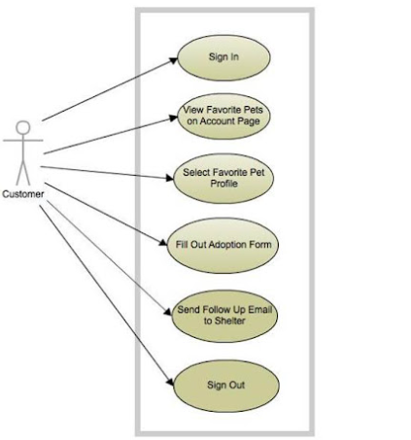

- Architecture Diagram:

1. Frontend Layer
This is everything you see and click on the website. It's like the physical shelter building with cute pet photos, colorful buttons, and easy navigation.
The beautiful pet cards with photos
The navigation menu at the top
The adoption form you fill out
The heart buttons you click to favorite pets
All the colors, fonts, and layouts
2. Data Layer
This remembers everything. It's like the shelter's filing cabinet and your personal notebook combined.
Stores all pet information (names, breeds, ages) in pets.json
Remembers your favorite pets in browser's memory
Keeps track of adoption applications
Holds pet care information

3. Logic Layer
This is the brain that makes everything work together. It decides what happens when you click things.
When you click "Dogs only" filter → it shows only dogs
When you click a heart → it saves that pet to your favorites
When you submit adoption form → it checks everything is filled
When you return tomorrow → it remembers your favorites
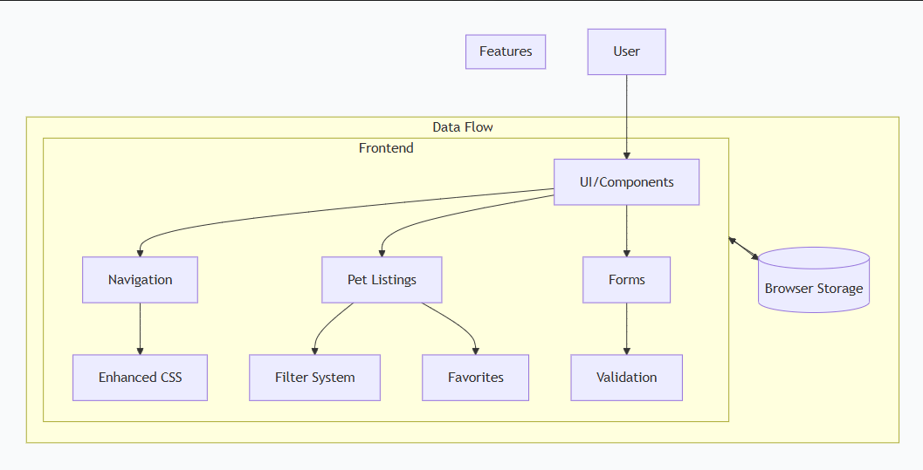
- Activity Diagram
An activity diagram is a visual flowchart that shows the step-by-step flow of activities in a system. Think of it as a "how-to guide" in picture form that answers: "What happens when someone uses this feature?".An activity diagram is essentially a visual storyboard that maps out every step of the user's journey through your system, transforming complex processes into clear, sequential flows that anyone can follow.
For Pet Adoption Portal, it vividly illustrates the complete narrative from the moment a visitor arrives at the home page to the final submission of an adoption application.This diagram acts as the project's circulatory system, showing how user interactions, system responses, and decision points
Activity Flow:
- User visits the Pet Adoption Portal website
- Lands on the home page with welcome message
- Navigates to the "Adopt" page using the navigation menu
- Views a grid of available pet cards
- Clicks on a filter button (e.g., "Dogs Only")
- System filters and displays only dogs
- User clicks on a specific pet card to view details and Reads the pet's information and description
- User decides if they like this pet
- If YES, clicks the heart button to favorite it
- System saves the pet ID to LocalStorage
- Heart button turns red to indicate saved status
- Clicks "Adopt Now" button on chosen pet
- System opens the adoption form page
- User fills in details
- User clicks the "Submit Application" button
- System validates all form fields- If any field is empty, shows error message
- Shows success message
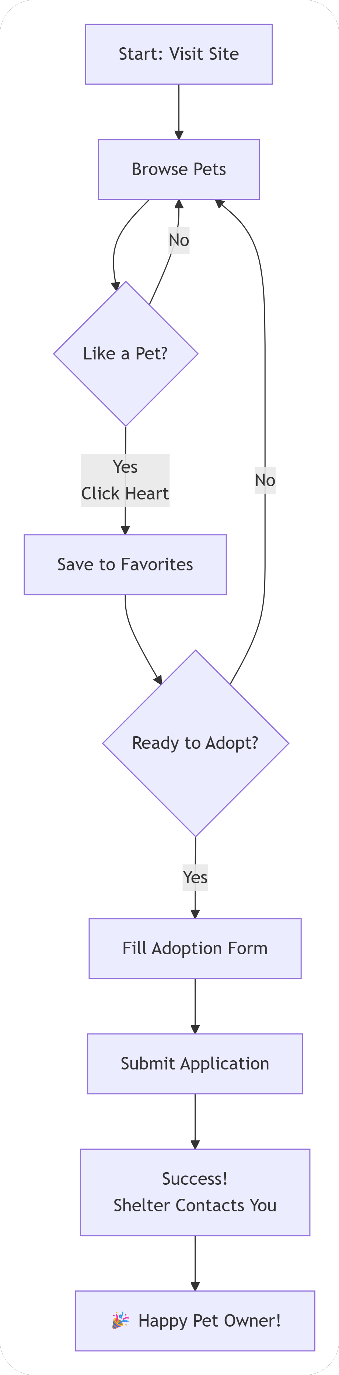

TESTING

Testing is a critical phase in software development that ensures the application functions as intended, meets user requirements, and provides a reliable and error-free experience. The Pet Adoption Portal underwent systematic testing to validate its functionality, usability, performance, and reliability. Since the application is frontend-based, emphasis was placed on manual testing, UI testing, and functional testing, along with proper documentation of bugs and fixes.
Importance of Testing:
- Ensuring all features work as expected
- Improving application reliability and performance
- Enhancing user experience
- Preventing data loss or incorrect calculations.
- TestCases:

Test cases are systematic procedures designed to verify that specific features of the Pet Adoption Portal function correctly. Each test case represents a unique user scenario or interaction with the application, outlining step-by-step actions to perform and expected outcomes to validate. This documentation covers end-to-end testing of all major functionalities across the application's five main pages. The testing approach ensures that every user journey—from browsing pets to submitting adoption applications—works seamlessly while maintaining responsive design across various devices.
Page | Feature | Test Steps | Expected Result | Status
All Pages | Navigation System | Click each navigation link, verify page loads, check active state styling | Correct pages load, active link shows gradient background, navigation fixed at top | PASS
Homepage | Pet Filtering | Click Dogs filter → verify dogs shown, click Cats filter → verify cats shown, click All Pets | Only filtered pets displayed, active filter has colored background, emoji icons visible | PASS
Homepage | Favorites Management | Click heart icon on pet card, observe animation, click again, navigate to Favorites page | Heart turns red with animation, toggles back to gray, favorites saved to localStorage, persists on refresh | PASS
Favorites Page | Favorites Display | Add pets to favorites, navigate to Favorites page, verify displayed pets, click Remove button | Correct pets displayed, details match homepage, Remove button works immediately, empty state shows when no favorites | PASS
Adoption Form | Form Submission | Click Adopt Now on any pet, fill all required fields, submit form, try empty submission | Form loads with pet info, success message shows, validation prevents empty submissions, error messages appear | PASS
Pet Care Page | Information Display | Navigate to page, scroll through content, click accordion sections, check all CTA buttons | Hero image loads, accordion expands/collapses properly, care cards display correctly, buttons clickable | PASS

- Manual Testing:

Manual testing is the process where a human tester manually interacts with the software application to identify bugs, verify features, and ensure everything works as expected without using any automated tools or scripts.

Manual Testing Activities Performed

1. Navigation Testing
Clicked all menu links (Home, Favorites, Pet Care, Login)
Verified correct pages load
Checked active page highlighting

2. Pet Filter Testing
Tested "Dogs", "Cats", "All Pets" filters
Verified correct pets show for each filter
Checked filter button active states

3. Favorites Testing
Clicked heart icons to add/remove favorites
Verified Favorites page shows correct pets
Tested Remove button functionality
Checked data persists after refresh

4. Form Testing
Filled and submitted Adoption For
Tested form validation (empty fields, invalid email)
Submitted Login Form with test credentials
Verified success/error messages

5. Responsive Testing
Tested desktop (1200px+), tablet (768px), mobile (375px)
Verified layout adjusts correctly
Checked touch targets on mobile
No horizontal scrolling issues
6.Cross-Browser Testing
Tested in Chrome and Firefox
Verified consistent functionality
Checked for visual differences

7. User Flow Testing
Tested complete adoption journey
Tested favorites management flow
Tested navigation between all pages
- UI Testing
Testing the visual appearance and user interface elements of the website.
Visual Consistency
Colors consistent across all pages
Fonts uniform throughout site
Button styles match everywhere
Spacing and padding consistent

Layout Testing
No overlapping elements
No cut-off text or images
Proper alignment maintained
Grid layouts display correctly
Navigation UI
Navigation bar fixed at top
Active page clearly highlighted
Hover effects work properly
All links clickable
Pet Cards Display
Images display without stretching
Text readable on all cards
Icons properly positioned
Button hover states work

4.Functional Testing
Testing that all features and functions of the website work correctly as specified.

Testing Performed:

Navigation Functions
All navigation links work correctly
Pages load when links clicked
Active page indication works
Browser back/forward buttons work

Pet Filtering Function
Filter buttons respond to clicks
Correct pets displayed for each filter
"All Pets" shows all pets
Filter active state updates correctly

Favorites System
Heart icons toggle add/remove
Favorites save to browser storage
Favorites page displays correct pets
Remove button deletes favorites
Data persists after page refresh

Form Functions
Adoption form submits successfully
Form validation prevents empty submissions
Email validation works
Phone number validation works
Success message displays after submission

Login Function
Login form accepts input
Form validation works
Remember me checkbox functions
Forgot password link accessible
Data Handling
LocalStorage saves and retrieves data
RESULTS

LOGIN PAGE:
It is a simple form where users enter their email and password to access their account. It includes a "Remember Me" option to stay logged in and a link for password recovery if needed. Once logged in, users can save their favorite pets and complete adoption applications.

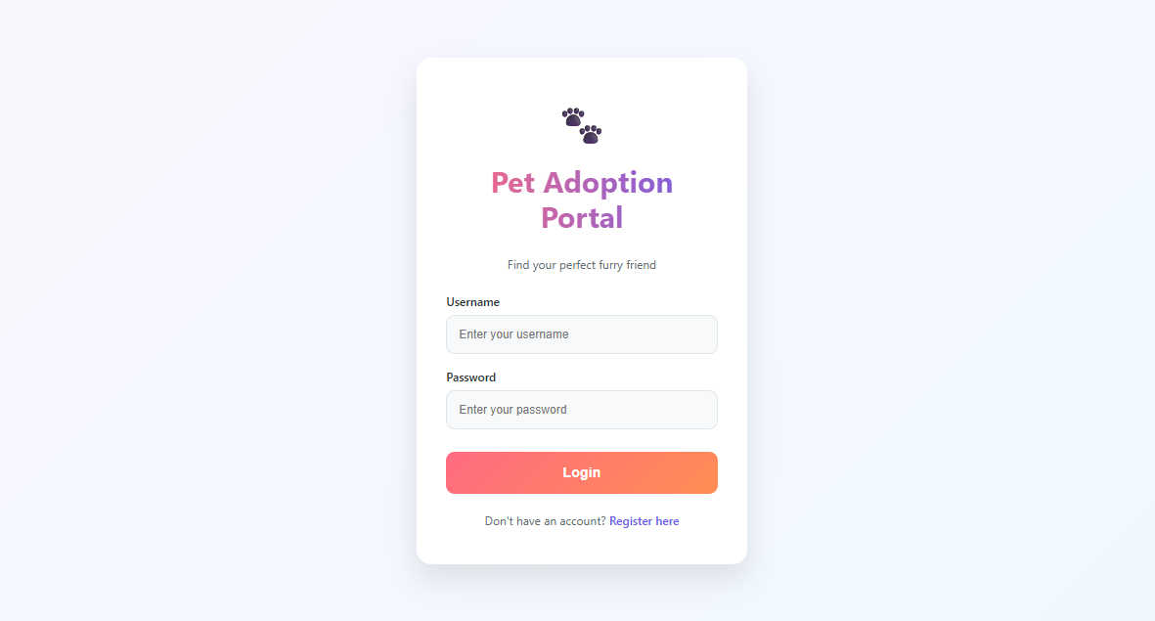

REGISTER FORM:

The register form in your pet adoption website is where new users create an account. It asks for basic information like name, email, password, and contact details. The form has the same clean design as the login page with matching colors and styling. After registering, users can log in to save favorite pets and submit adoption applications more easily.
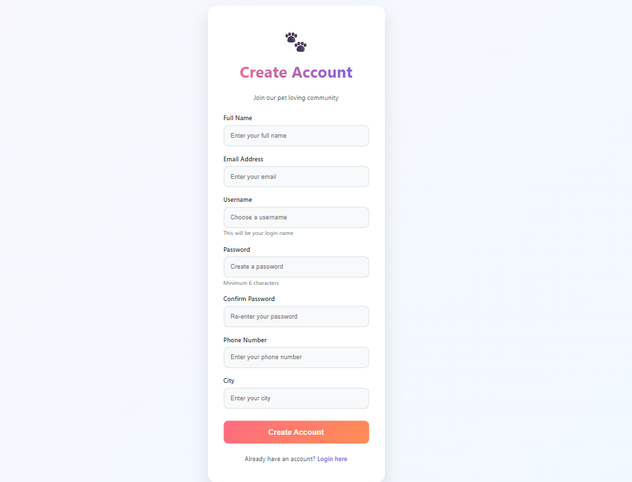

HOME PAGE:
The home page is the main landing page of your pet adoption website.

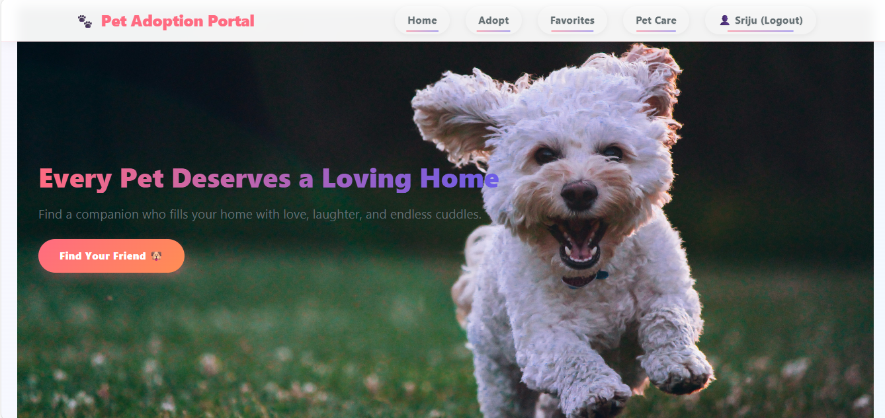

ADOPT PAGE:

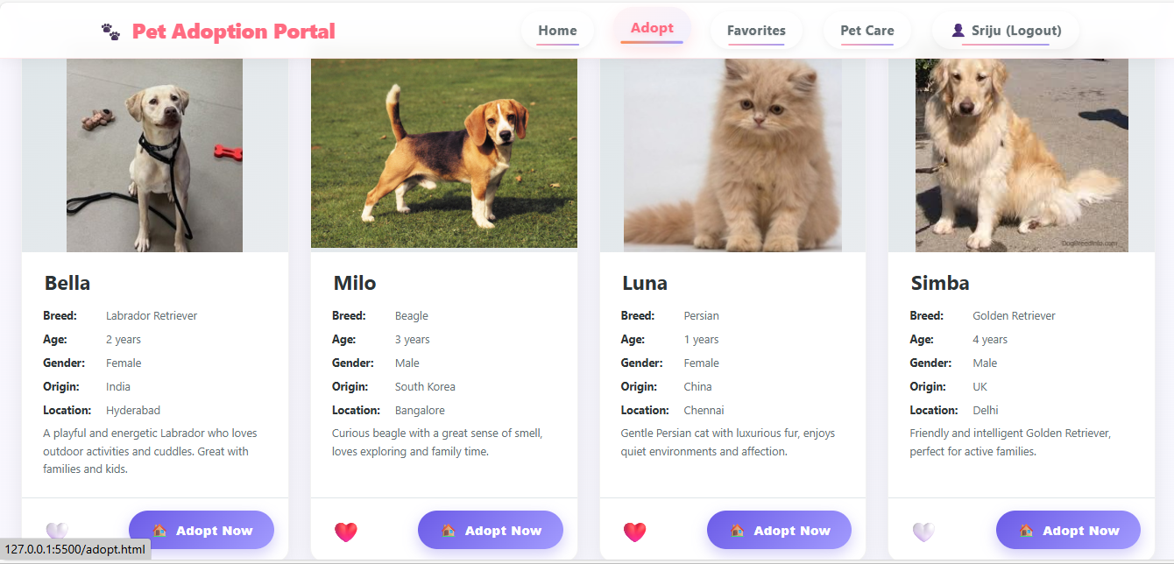

FAVORITES PAGE:
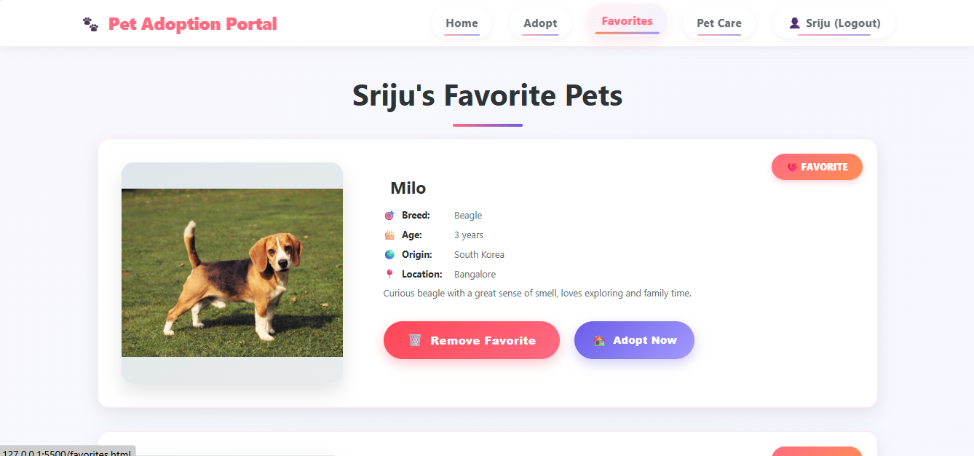
PET CARE PAGE:

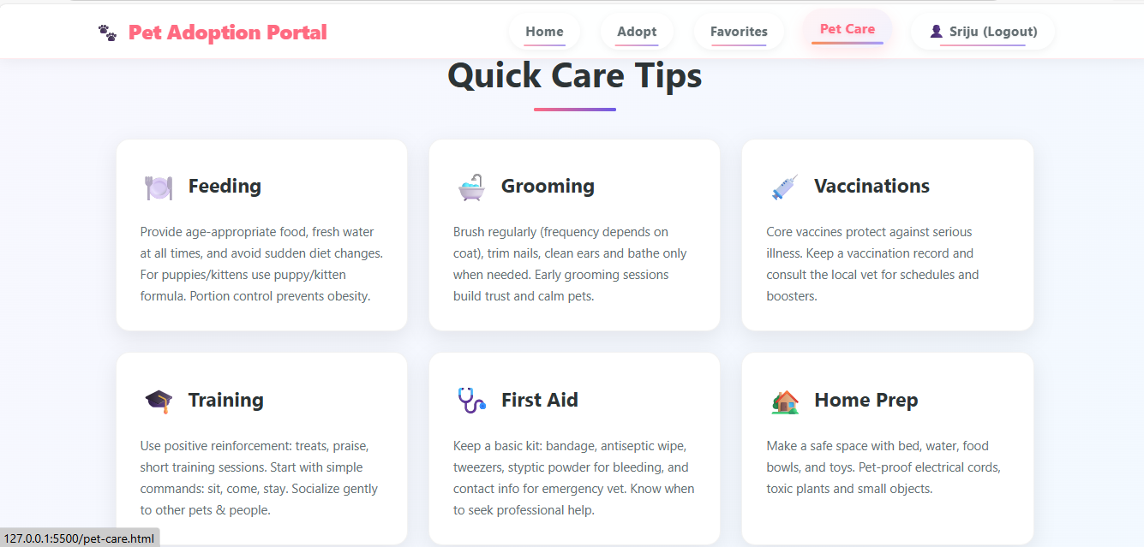

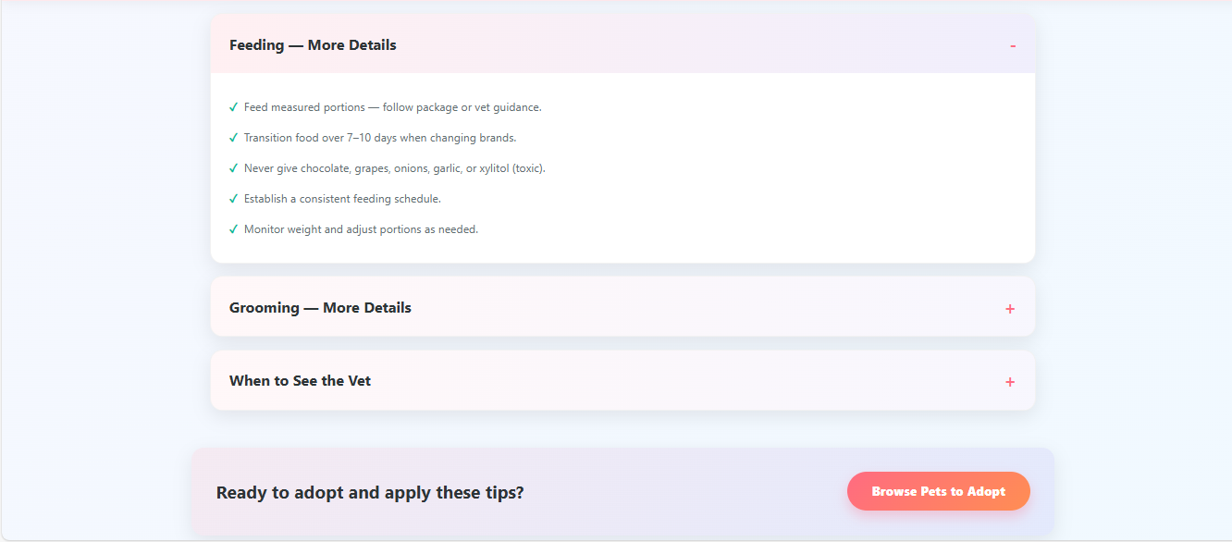

ADOPTION APPLICATION FORM:

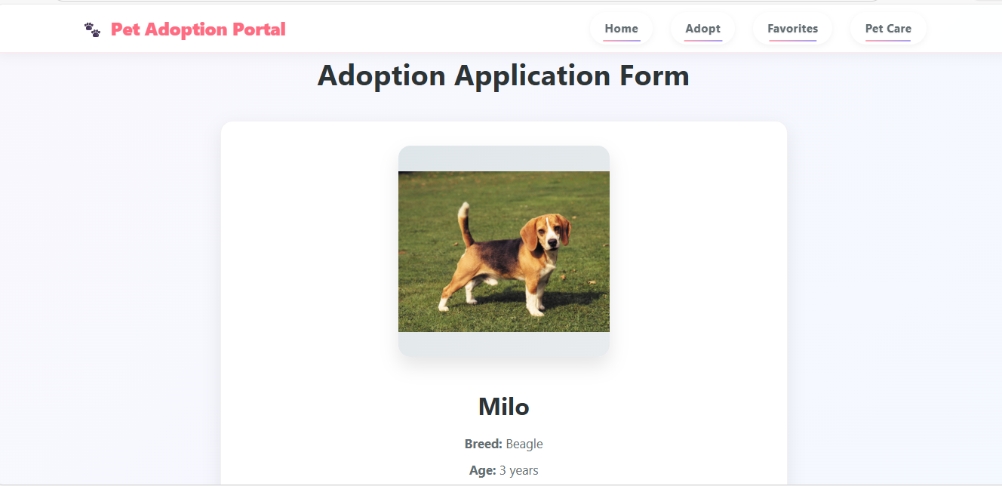

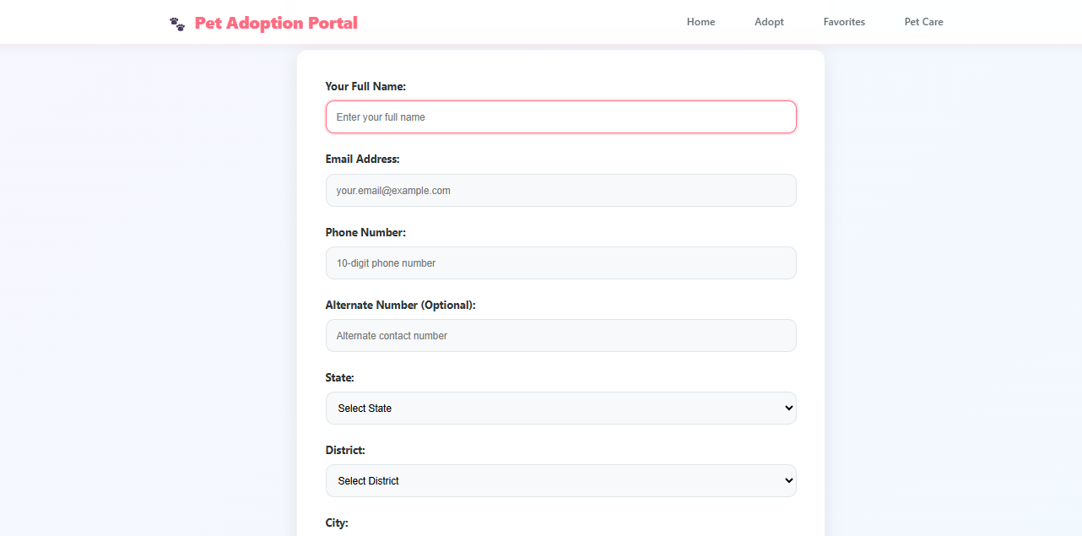

SUBMISSION :

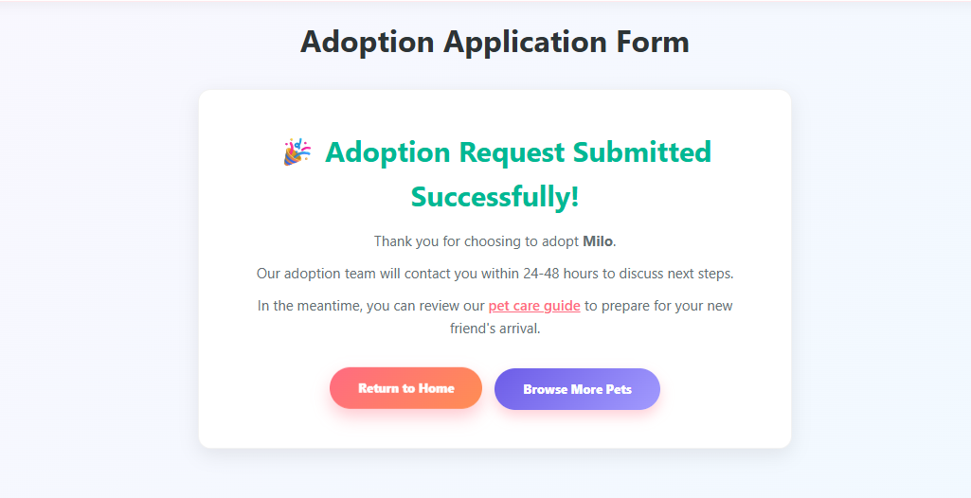

Performance Results:

Application Load Time:
The platform loads quickly as it relies on browser storage only
Pet data loads from Local Storage within milliseconds
No noticeable delay during page refresh or navigation
All pages load within 1.3 seconds

Data Persistence Performance:
Pet favorites stored in Local Storage remain intact after browser refresh
Saved favorites are accurately retrieved and displayed
Data consistency maintained across user sessions
Form data persists during multi-step processes

Page Rendering and Responsiveness:
Pet listings and cards render smoothly without delay
User actions (favorites, filtering) update instantly
Interface remains responsive with current pet dataset
Hover effects and animations perform smoothly

Browser Compatibility:
The application performed consistently across:
Google Chrome
Mozilla Firefox
Microsoft Edge
Safari (iOS)
No layout distortion, performance degradation, or functionality issues detected.

Feature Demonstration

Pet Browsing and Selection:
Users can browse available pets and view detailed information before making decisions.
Demonstration Steps:
Open the homepage
Browse or filter pet listings by category
View pet details (breed, age)
Select a pet of interest
Favorites Management:
The favorites feature allows users to save pets for future references
Users can add pets to favorites list
Saved pets can be viewed or removed anytime
Favorites stored persistently using Local Storage
Heart icons provide visual feedback
Adoption Request Process:
The system enables users to submit adoption requests smoothly.
Process Flow:
User selects a pet and clicks "Adopt Now"
Fills adoption request form with details
Form validation ensures complete information
Success confirmation displayed immediately

Real-Time Status Updates:
The platform provides immediate feedback to users.
Updates Include:
Favorites status updates instantly
Filter results change in real-time
Form validation feedback immediate
User actions acknowledged with visual cues

User Experience Evaluation:
Based on testing and real-time usage:
Positive Aspects:
Interface is visually appealing and easy to navigate
Users can browse and interact without technical knowledge
Clear visual layout improves decision-making
Color-coded feedback aids user understanding

CONCLUSION

The project demonstrates the effective application of frontend web development concepts to address a real-world problem related to animal welfare and responsible pet adoption.

Summary of the Outcome:
The Pet Adoption Portal was successfully designed and implemented as a frontend-based web application that connects adoptable pets with potential adopters. The platform provides an intuitive and visually engaging interface for browsing available pets, viewing detailed pet profiles, managing favorite selections, and submitting adoption requests. Users can easily navigate through different modules such as the dashboard, adoption page, favorites page, and contact page.
The system efficiently manages pet and adoption-related data using browser-based Local Storage, ensuring fast data access and persistence without the need for backend infrastructure. Real-time updates to pet availability and adoption status improve transparency and user trust. The overall system fulfills all functional requirements and delivers a reliable, user-friendly solution that simplifies the pet adoption process and promotes responsible adoption.

Student’s Learning:
The development of this project provided valuable hands-on experience in modern frontend web technologies and application design. The student gained practical knowledge of HTML5 for content structuring, CSS3 for responsive and visually appealing layouts, and JavaScript for implementing dynamic interactions and real-time updates. The use of Local Storage helped the student understand client-side data management, persistence, and structured data handling.
The project also strengthened problem-solving and logical thinking skills, particularly in managing user interactions, handling adoption workflows, and updating application states dynamically. The student improved skills in UI/UX design, testing, debugging, and documentation. Additionally, working on this project enhanced the student’s understanding of real-world application development, bridging theoretical concepts with practical implementation.

11.3 Success of the Project:
The Pet Adoption Portal can be considered a successful project as it meets all its intended objectives and delivers a functional, efficient, and user-friendly system. The application performs consistently across different web browsers and provides smooth navigation and responsive interaction. Core features such as pet browsing, favorites management, and adoption request handling operate accurately and without performance issues.
The project demonstrates the feasibility of developing a complete and scalable application using only frontend technologies. The positive results observed during testing and feature demonstrations validate the effectiveness of the system design and implementation. Overall, the project stands as a successful academic and practical achievement, showcasing the student’s ability to design, develop, and document a meaningful real-world web application.
This chapter summarizes the overall outcome of the Pet Adoption Platform project, highlights the knowledge and skills gained by the student during development, and evaluates the success of the project in achieving its objectives. The project demonstrates the effective application of frontend web development concepts to address a real-world problem related to animal welfare and responsible pet adoption.

FUTURE ENHANCEMENTS

Backend Integration & Database
Add a real server and database so shelters can manage pets and users can have proper accounts that work across all devices.
Details: Build a Node.js backend with PostgreSQL to store pet info, user profiles, adoption forms, and shelter data. Create REST APIs for all operations. Add an admin dashboard where shelter staff can add/update pets, view applications, and mark pets as adopted.
Mobile Application
Create phone apps for iOS and Android so users can browse pets and get notifications directly on their mobile devices.
Details: Develop native apps using Swift for iPhone and Kotlin for Android with push notifications for new pets, adoption status updates, and appointment reminders. Include offline access to saved pets and favorited profiles.
Advanced Search System
Add better search filters by location, age, size, and pet personality to help users find their perfect match more easily.
Details: Implement geolocation-based search, advanced filters (energy level, good with kids/pets, special needs), saved search alerts, and voice search functionality.
Social & Community Features
Let users share adoption success stories, rate shelters, and connect with other pet owners in community forums.
Details: Build user profiles with pet photo galleries, create discussion boards for pet care advice, add shelter review systems, and enable social sharing to Facebook/Instagram.
Payment & Donation System
Allow users to pay adoption fees online and make donations directly to shelters through secure payment processing.
Details: Integrate Stripe/PayPal for secure transactions, create donation tracking with receipts, enable pet sponsorship programs, and set up recurring monthly donations.
AI & Smart Features
Use image recognition to identify pet breeds from photos and AI chatbots to answer common questions automatically.
Details: Implement Google Vision API for breed detection, add an AI chatbot for 24/7 user support, and develop match algorithms suggesting pets based on lifestyle surveys.
Multi-language Support
Translate the platform into multiple languages so more people worldwide can use it to find pets.
Details: Add language selector for Spanish, French, Mandarin etc., translate all content, localize date/currency formats, and implement auto-translate for user-generated content.
Emergency Support Features
Add tools for lost pet reporting, emergency fostering, and connecting people with pet food banks during crises.
Details: Create lost/found pet matching system, emergency foster network signup, disaster response resources, and pet food bank locator with availability status.
Technical Upgrades
Rebuild with modern frameworks like React for better performance and easier maintenance as the platform grows.
Details: Migrate to React.js component architecture, implement GraphQL for efficient data fetching, add PWA capabilities for app-like experience, and use Docker for easier deployment.

REFERENCES

Books:
- Duckett, J. (2014). HTML and CSS: Design and Build Websites. Wiley Publishing.
– Provided foundational knowledge on structuring and styling web pages.
- Duckett, J. (2015). JavaScript and jQuery: Interactive Front-End Web Development. Wiley Publishing.
– Helped in understanding JavaScript logic, interactivity, and dynamic UI development.
- Norman, D. A. (2013). The Design of Everyday Things. Basic Books.
– Offered insights into user-centered design and usability principles.
- Shwetz, A. (2017). Pet Adoption and Welfare Management Systems: A Guide for Developers. TechPress Publishing.
– Provided guidance on designing adoption platforms and integrating welfare management features.

Research Papers:
- Patronek, G. J., & Rauch, A. (2007). Systematic Review of Shelter Programs for Companion Animals: Adoption, Rehoming, and Outcomes. Journal of Applied Animal Welfare Science, 10(3), 198–214.
- Wells, D. L., & Hepper, P. G. (2000). Pets and Human Well-Being: Exploring the Link Between Pet Ownership and Psychological Health. Anthrozoös, 13(2), 76–84.
- Serpell, J. A. (2019). The Domestic Dog: Its Evolution, Behavior and Interactions with People. Cambridge University Press.

Websites:
- Petfinder. Pet Adoption Resources and Shelter Listings.
https://www.petfinder.com
- ASPCA. Animal Welfare and Adoption Guidelines.
https://www.aspca.org
- Humane Society. Pet Adoption and Shelter Best Practices.
https://www.humanesociety.org
- GeeksforGeeks. Web Development Resources and Tutorials.
https://www.geeksforgeeks.org

Others:

1. MERN Pet Adoption Web Application
A full web app where users can view, add, and adopt pets. Includes backend with Node.js, Express, MongoDB, frontend with React & Redux, image uploads, and search.
https://github.com/sahanrashmikaslk/MERN-PetAdoptionWebApplication GitHub

2. Pet Adoption Platform (Full Stack + Firebase)
Comprehensive platform that includes:
User authentication
Role-based access (Admin/User)
Pet listings with images & description
Donation integration
Live demo and GitHub repo available.
https://github.com/Rahidapriya/Pet-Adoption-Platform GitHub

3. Pawfect Match – Pet Adoption Website
A project showcased on Devfolio with searchable pet listings, filtering, and adoption processes.
🔗 https://devfolio.co/projects/pawfect-match-pet-adoption-website-886c Devfolio

4. Pet Shelter Adoption Website
Static/interactive site to browse dogs and cats available for adoption, originally deployed with visuals and pet listings.
https://github.com/deepavadakan/Pet-Shelter-Adoption-Website GitHub

5. Need A Puppy? (Capstone Project)
A pet adoption website with responsive design and backend API (Node & Express).
https://github.com/keith-flynn/pet-adoption-website GitHub

6. PawFinds – MERN Stack Pet Adoption System
Includes full functionality like admin review of adoption requests, filtering, and detailed pet profiles.
https://github.com/KaShiekzmi/PawFinds-A-Pet-Adoption-System-MERN-Stack-Portfolio-with-Admin-Panel GitHub

7. Flutter Pet Adoption App (Mobile)
A mobile-first pet adoption app with account settings and favorites.
https://github.com/sangvaleap/app-flutter-pet-adoption

